Why LLMs Charge Per Token: The Compute Behind a Single Query
LLMs are ubiquitous nowadays and almost every day we interact with them and probably multiple times. They appear magical when we just enter simple prompt and they generate coherent text as result.
However, behind every query, there lies a complex sequence of matrix multiplication (around 90% of entire inference processing is Matrix Multiplication only). By now, we have also seen that in general, there are token limits associated with our LLM models subscription.
In this blog, let us see that:
Why the token count has become the unit of LLM usage calculation and how prompt length affects the compute

Why the token count has become the unit of LLM usage calculation: To understand this part, let’s discuss what happens when we send a prompt to an LLM.
If we take a prompt “How do birds fly?” for a GPT (which is based on transformer architecture), the output generation will follow the below steps:
Step 1) This prompt will be first converted to tokens which may be {‘How’, ‘ do’, ‘ birds’, ‘ fly’, ‘?’} = 5 tokens. There are several algorithms available to convert the prompt to tokens. One popular is Byte Pair Encoding (BPE).
Step 2) These tokens will be assigned numeric values, which are called token Ids. These are like dictionary mapping {vocab, ID}. This is necessary because all the calculations need to happen on the numbers. These Ids do not contain any semantic meaning, and they are just integer labels.
Step 3) These tokens IDs will now be converted to Embeddings to capture the relation among them i.e. semantic meaning. Some methods are: Word2Vec, Learned Embedding Matrix.
In case of GPT-2, tokens Ids are mapped to the rows of embedding matrix of size (vocab_size=50257 x hidden_diemension=768) inside the model. So, for the 5 tokens, we will get 5 rows from this GPT-2 embedding matrix and each row is one row vector.
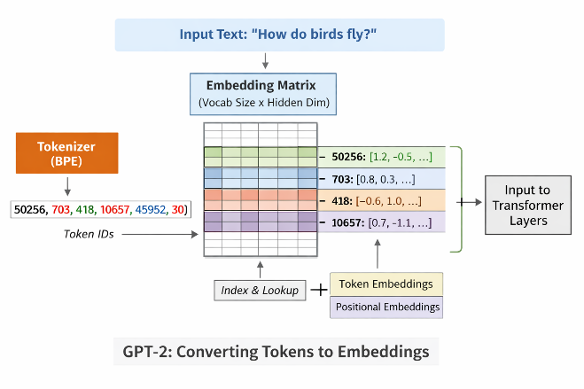
(Image for illustrative purpose)
Each of these 5 vectors are added with positional embeddings, so that the model knows the order of the tokens in the sequence. While the original transformer in the paper “Attention is all you need” uses sinusoidal positional encoding, GPT-2 uses pre-learned positional embedding using training. So, it is kind of a lookup table.
The positional Embedding Matrix in GPT-2 model is of size 1024 x 768 (max_seq_len x d_model))
Pos0: How
Pos1: do
Pos2: birds
Pos3: fly
Pos4: ?
All these Positional Encoding will be a vector of 768 length.

These 5 Embedding vectors of 768 length and 5 Positional vectors of 768 length will be added and then fed to the transformer.
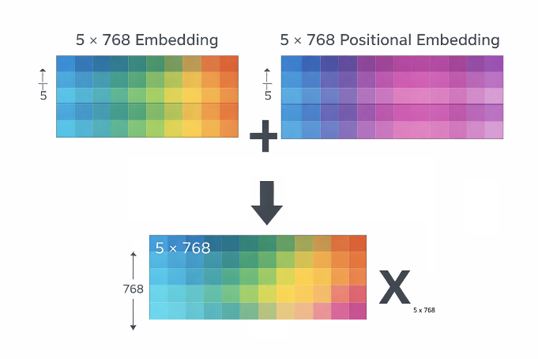

Step 4) In the transformer, only decoder layer will be used. This entire step explains the processing in one layer of GPT-2. There are such 12 layers doing the same sequence of operations.
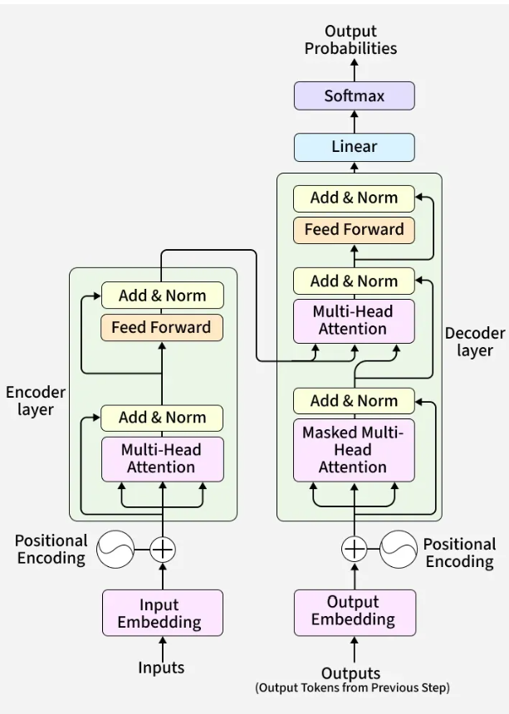
4.1) Masked Multi-Head Self-Attention: Inside the transformer, there are three pre-learned weight matrices used:
Query Matrix = ${Wq }_{768 X 768}$
Key Matrix = ${Wk }_{768 X 768}$
Value Matrix = ${Wv }_{768 X 768}$

The output matrix ‘X’ of size (5x768) obtained in the previous step, are multiplied with all these weight matrices to get the self attention. Masking (setting value to -inf) of the future tokens are applied to ensure that each position can only attend the past and present tokens, i.e. enforcing causality. With this multiplication, the below Q, K, V matrices are computed.

$Q_{5 X 768}$ = $X_{5 X 768}$ . ${Wq }_{768 X 768}$ (Queries)
$K_{5 X 768}$ = $X_{5 X 768}$ . ${Wk }_{768 X 768}$ (Key)
$V_{5 X 768}$ = $X_{5 X 768}$ . ${Wv }_{768 X 768}$ (Values)

Attention scores are computed using QKᵀ, allowing each token to attend to other tokens in the sequence.
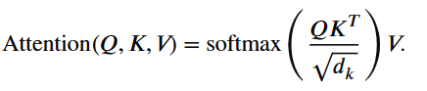
Where:
Q = Query Matrix
$K^{T}$ = Transpose of Key Matrix
V = Value Matrix
$d_{k}$ = Dimension of key vectors for each attention head = 768 / 12 (number of heads) = 64

($d_{k}$ is used to prevent the dot product from growing too large)

4.2) Feed Forward Neural Network: Each token vector then passes through a two-layer fully connected network with a nonlinearity (usually GELU) to further transform the representation. In GPT-2, the output vectors of 5 x 768 are transformed to 5 x 3072, then applied Non-linear activation and then scaled back to 5 x 768.
4.3) Residual connection and Layer Normalization: The FFN output is added back to the input of the FFN block. This helps preserve earlier information and stabilizes deep networks. The combined vector is then passed through LayerNorm, which normalizes the values to improve training stability.
Now this output is again passed to the next layer of the transformer decoder block.

Step 5) Softmax for the next token prediction: Once 12 layers are done with processing, softmax is applied to produce the probabilities for all the vocabulary tokens and the highest probability token becomes next generated token.
This simply means that, after all these calculations, the model has generated just ONE WORD output (actually, it is one token, but for simplicity we will take one word).
Input: Why do birds fly?
Output token: Because
New input: Why do birds fly? Because

And then the process repeats as LLMs are autoregressive in nature, which mean the previous generated output is fed to predict next token.
Of course, there are optimization techniques like KV caching to avoid recomputing the previous parts, but I hope you get the idea.

Now coming to the cost part:
In this entire process of Q$K^{T}$calculation, in GPT-2
(T x $d_{k}$).( $d_{k}$ x T) = $d_{k}$ multiplications $T^{2}$ times for 12 heads and 12 layers
So, attention compute complexity is directly proportional to $T^{2}$, where T = number of input tokens.
Number of Tokens (T) | Attention Operations growth
5 | 25
100 | 10,000
1000 | 1,000,000

This is why the token count becomes the unit of LLM usage calculation.
By now as we understand the token length matters a lot. So,
Prompt1 = “How do birds fly?”
Prompt2 = “Hi, please tell me how do birds fly?”

Are not same for the GPTs when it comes to the computation.

